**The true Antarctic species, those that breed on or near continental Antarctica**

[More](https://www.coolantarctica.com/Antarctica%20fact%20file/wildlife/adelie-penguin.php)

**Emperor penguin**Aptenodytes forsteri  
  
[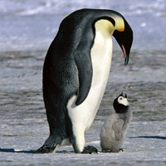](https://www.coolantarctica.com/Antarctica%20fact%20file/wildlife/emp14.jpg)

**Height**: 1.15m - 3.8ft  
  
**Weight**: 30kg - 66lb **Breeding Season:**  
April - December **Distribution:**Continental Antarctica on the sea-ice, the most southerly of all species of penguins. **Estimated population:**  
238, 000 breeding pairs,  
595, 000 individuals

[More](https://www.coolantarctica.com/Antarctica%20fact%20file/wildlife/Emperor-penguins.php)

**King penguin**Aptenodytes patagonica

[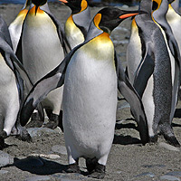](https://www.coolantarctica.com/Antarctica%20fact%20file/wildlife/kings8.jpg)

**Height:** 95cm - 3.1 ft  
  
**Weight:** 15kg - 33lb  **Breeding Season:**  
Starts in November or January, complex breeding system, early or late breeders - raise 2 chicks every 3 years.  
  
**Distribution:**sub-Antarctic islands 46° to 55° South. Biggest colony is on South Georgia. **Estimated population:**  
2 to 3.2 million breeding pairs

[More](https://www.coolantarctica.com/Antarctica%20fact%20file/wildlife/King-penguins.php)

**Rockhopper penguin**Eudyptes crestatus

[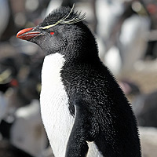](https://www.coolantarctica.com/Antarctica%20fact%20file/wildlife/Rockhopper_Penguin_Liam-Quinn-from-Canada-CC2SaSA.jpg)

**Height:** 55cm - 21.6 inches  
  
**Weight:** 2.5kg - 5.5lb  **Breeding Season:**  
December - March **Distribution:**  
Falkland islands and sub-Antarctic islands north of the Antarctic convergence. **Estimated population:**  
1.8 million breeding pairs  
Many populations are in decline by 40% and up to 94% for certain colonies.

**Antarctica** is the coldest continent on earth, and has a**climate** of extremes. The continent is snow- and ice-covered, with freezing temperatures all year round. So-called "Catabian winds" can cause violent snowstorms that can last for days, and sometimes even weeks, making it very dangerous to stay outside.

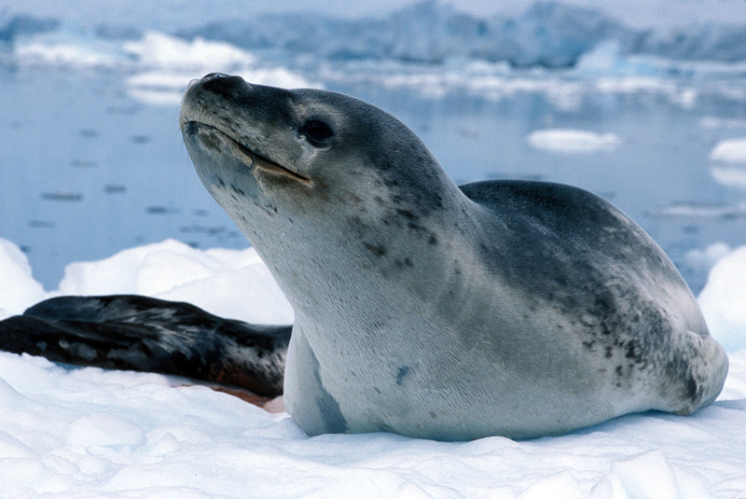

## **They’re the Third Largest Seal in the World**

## Female leopard seals, the larger of the two sexes, can reach weights of 590 kilograms (1300 pounds), and grow to lengths of up to three meters (10 feet). Their bodies are long and slender, and their heads appear to be almost a little too large for their thin, serpent-like bodies. This specialized streamline body shape is excellent for propelling them through the water at speeds of up to 25 miles per hour. Elephant seals and Walrus are larger than Leopard seals. **Leopard Seals are Exceptionally Solitary Animals**

## Leopard seals do not play well with others! Generally, they hunt alone and are typically never seen with more than one or two other individuals at a time. Exceptions to this solitary behavior include the annual breeding period from November to March, when multiple individuals will aggregate together. Due to their exceptionally nasty demeanor and solitary nature, however, little is known about their entire reproductive cycle. Scientists are still trying to figure out how leopard seals choose their mates and how they establish territories. **Sometimes They Smile!**

The ends of the leopard seal’s mouth are permanently curled upward, creating the illusion of a smile or menacing grin. This feature adds to their already intimidating presence, and is not to be trusted. However happy they may be to see you, they are potentially aggressive animals that will always be keeping an eye out for the next meal. In the rare occasion that they haul out on land, they’ll defend their personal space by issuing a warning growl at anything that comes too close.